UI errors
Workshop #04
Flutter Developer Bootcamp

Purpose
This workshop demonstrates how to fix the UI errors.

Problem
In the given workshop scenario, an overflow error occurs when users input data into a text field. You aim to resolve this overflow error.

How to Solve
1. Checkout the workshop from Git Repo:
git clone -b <user-branch> <repo-URL>
2. Open the root folder inside VS Code
3. To build the app click the run option in the main method { }
4. Fix the app's interface issue by using some widgets.

You Will Achieve

When you complete this workshop, you will learn how to handle UI errors in the application, and you will also learn how to create an application without any overflow errors.

Screenshots

Before implementation (Without Error Handling)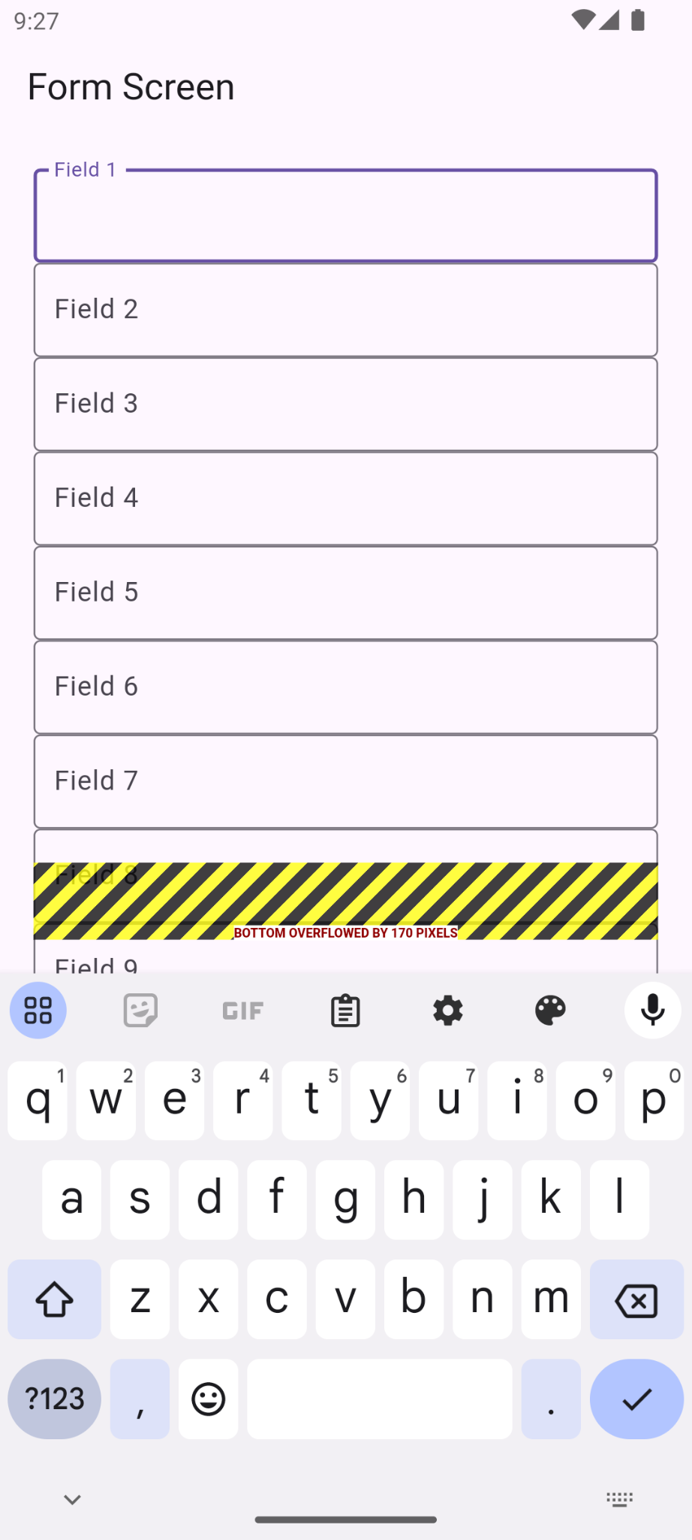

After implementation (With Error Handling)
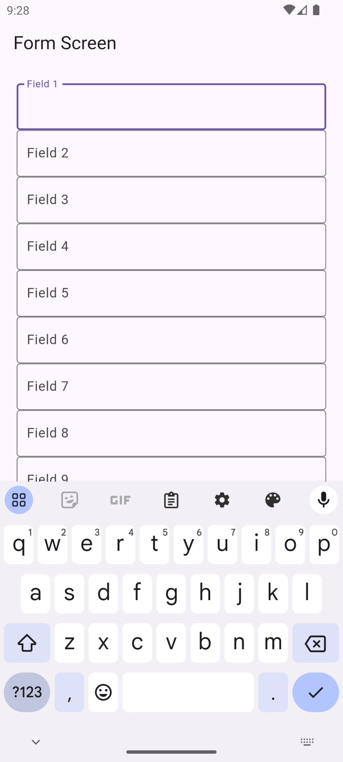

How to submit your workshop
Push your project back to the same git branch using command:
<command name>

Happy Coding!

